AreaScale User Guide
Overview
This guide explains how to install and use the AreaScale script in Adobe Illustrator. This script automatically resizes club logos to specific surface areas based on their intended use (club logo, cap, beanie, etc.).
Why We're Using Surface Area
Previously, we used set dimensions for club logos:
- Club logo: 7.5cm high or wide.
- Cap logo: 6cm high or wide.
- Beanie, sunhat, sliders, bucket hat: 4.5cm high or wide.
We are now changing to a surface area-based approach for more consistent sizing across different logo shapes:
- Club logo: 45cm²
- Cap logo: 25cm²
- Beanie, sunhat, sliders, bucket hat: 15cm²
The AreaScale script automatically scales the logo to the correct surface area, ensuring consistent visual impact regardless of whether the logo is square, rectangular, circular, or any other shape.

How to Install AreaScale:
The AreaScale script needs to be installed locally in you Adobe Illustrator Script Folder. Please follow these steps:
Step 1: Locate and Copy the Script File
Copy the file titled AreaScale.jsx from this WebDAV location:
store-9ong3twio7.mybicommerce.com → WebDAV → content → 00 – Adobe Scripts
Step 2: Install the Script
Paste the script into your Adobe Illustrator Scripts folder. The default path on Windows is:
This PC > Local Disk (C:) > Program Files > Adobe > Adobe Illustrator > Presets > en_GB > Scripts
Important Note: Administrative privileges may be required to copy files to this location. If you need assistance, contact Sentinel at support@csgroup.co.uk and reference this guide.
Step 3: Restart Adobe Illustrator
Once the script has been installed, restart Adobe Illustrator for the changes to take effect.

How to Use AreaScale
Step 1: Select and Group Your Logo
Click to select the logo you want to resize.
If the logo consists of multiple elements, group them together (Ctrl+G).

Step 2: Open the AreaScale Script
Navigate to File > Scripts > AreaScale
A dialog box will appear displaying preset sizes for different logo types.
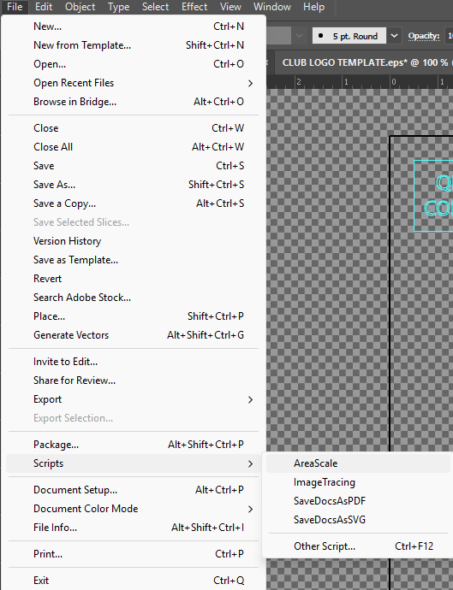
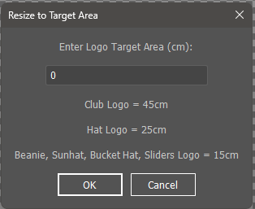

Step 3: Enter the Target Surface Area
Type the desired surface area into the input field
Click OK or press Enter
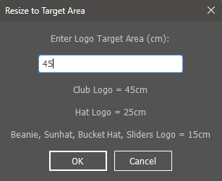

Step 4: Review the Results
A second dialog box will display the resize results, showing:
- Original surface area.
- New surface area.
- Scaling percentage applied.
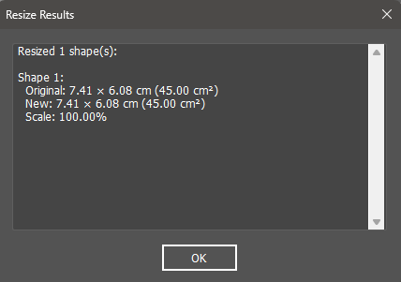
Click OK to confirm and complete the resize.

Step 5: Complete
Your logo has been successfully resized to the specified surface area and is ready to use.

Support
For support with installation, contact:
- Sentinel Support: support@csgroup.co.uk
For support with using this script, contact:
- Freddie Harris: freddie.harris@nx-teamwear.com

